The EC Barefoot Council in cooperation with the German Waterski- and Wakeboard Federation is organizing an international official seminar. All officials (from beginners to level2) are welcome to join.
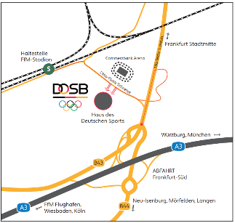
When: 19.+20.03.2022
Where: Deutscher Olympischer Sportbund (DOSB) e.V.
Otto-Fleck-Schneise 12
60528 Frankfurt am Main

The seminar will take place in Frankfurt a.M., Germany. The best officials of europe (like Ludo Vrancx, Andy Harris, Paul Turner, etc.) will be there.
The clinic will start on Saturday 10am with a theoretical part (including scoring software, EMS-System, rule changes, scoring, judging, homologation, …). On Sunday we will do some quizzes – a requirement for every official. Please register yourself on the World barefoot Council homepage for the quizzes before this seminar.
There are several hotels in the City of Neu-Isenburg just a few minutes per car away.
Official Hotel: Leonardo Hotel Frankfurt City South Isenburger Schneise 40, 60528 Frankfurt am Main
We have a contingent of 15 single-rooms at the hotel till 04.03.2022. We can offer you a special deal for the rooms of 50€ per night (+20€ for a double-room). Please make your reservation via mail reservations.frankfurt@leonardo-hotels.com (reservation code: barefoot). We would like to organize a dinner on saturday evening. Please let us know if you would like to join the seminar and the saturday dinner asap.
If you need a pickup from the airport, please let us know, too.

For more information/registration contact: Svenja Hempelmann Svenja.hempelmann@dwwv.de
